Interactive Perceptual Representation in Autonomous Agents
application to unsupervised categorization of binary time series

Jean-Christophe BUISSON, Jean-Luc BASILLE

IRIT (Institut de Recherche en Informatique de Toulouse)
ENSEEIHT, 2 rue Camichel, 31071 TOULOUSE (France)
buisson@enseeiht.fr, basille@enseeiht.fr

Abstract : This paper shows that the only way for an autonomous agent to create new perceptual representations, entrenched in reality, is to use interactive sequences of action / anticipations, which provide a crucial internal error criterion. The necessary properties of these interactive representations are characterized.
This theoretical framework is illustrated with an operational model of active perception, which is applied to the inductive categorization of binary time series. This model, based on the assimilation/accommodation process described by the Swiss psychologist Jean Piaget, learns to recognize patterns in a time series, in an unsupervised way. It acts in orientating its perceptual apparatus, and anticipating the next sensory inputs; such a sequence of action / anticipated sensations forms an interaction, the goal of which is to assimilate (with concomitant accommodations) the current situation. The current interaction is influenced by past interactions and serves as a guide for future ones, creating a framework for learning.

Key-Words : inductive categorization, active perception, Piaget, interactivism, time series analysis.

- Introduction
This paper presents the first results of a larger research effort, aiming in the long term at creating machines or programs exhibiting a sensori-motor intelligence, of the kind which can be observed in primates or infants, before the emergence of the symbolic function. The expression sensori-motor intelligence has been first introduced by the Swiss psychologist and epistemologist Jean Piaget, who studied this stage with analyses drawn from scores of extraordinarily detailed and profound observations on his own three children [1,2]. At the heart of Piaget’s theories is the idea that it is through its activity that a child acquires all knowledge. This activity is structured in sensori-motor schemes, assimilating the sensorial reality with concomitant accommodations. Both assimilation and accommodation functions are analogous to their biological counterparts, where an organism keeps a cyclic process in activity (for example the digestion), integrating elements of the outside at each stage. Assimilation is the conservative process which keeps the organism structures intact, despite the addition of external elements: after eating a rabbit, a fox is still a fox. Accomodation is the process by which the assimilating structures adjust to reality in order to function properly. These adjustments may lead to the creation of new assimilating structures, by differentiation of existing structures.
This conceptual model of assimilation/accommodation can be applied from the biological level up to highest levels of cognitive and social activities [3], but this generality makes difficult its modelling for a given activity, in such a concrete way as to be simulated on computers. Gary Drescher [4] did it in a micro-world of blocs, and made a one-armed, one eyed simulated agent reconstruct the main developmental milestones described by Piaget, including the construction of causality, the fusion of the different sensorial modalities, and the construction of the notion of object.
The present work focuses on perceptual activity, and we will show that the perceived objects and situations are foods, assimilated by the perceptual structures of our models. Accommodation of these structures to reality will take two forms. The first form is a simple adjustment of existing perceptual structures to reality, which will lead to a synchronisation and an adjustment of sensors; a second form, of an inductive nature, will create new perceptual structures by differentiation of existing structures.
The rest of the paper is in three parts. A first theoretical part will analyse the necessary conditions for a perceptual representation to be a representation for the agent itself, and we will show that these conditions are not met by most approaches. A second part will illustrate these ideas with a simple example of unsupervised learning in a task of rhythm recognition in a binary time series. The last part will provide some conclusions.

2. The emergence of perceptual representations in autonomous agents
This problem is actively studied by the autonomous agents research community [5, 6, 7, 8]. For example, the Scheier’s robot [6] moves in a world of blocks, some of them being textured and electrically conductive, the others being non-textured and non-conductive. The robot is equipped with a high definition CCD camera and haptic sensors, and its task is to visit all conductive objects. Eventually the robot learns that the conductive blocks are the textured ones, and uses this knowledge to go faster, guided by visual cues. The Scheier’s model is inspired by Edelman’s work on reentrant maps [9]; in a way similar to our approach, it includes the actions of the agent in the classification process in order to reduce the too many degrees of freedom of the sensorial state space.
2.1 Do internal states constitute representations for the agent itself?
When the Scheier’s robot faces a conductive, textured block, the visual and haptic sensors activate specific neurons, associated to this situation. The block might be seen from a large number of different angles, with varying lighting conditions, but it is undeniable that correlations do exist between these internal states, and that, when faced with a non-textured, non-conductive block, other internal states, with other correlations are present.
What we do contest, and which is taken for granted by the great majority of authors, is that these classes of internal states constitute representations for the agent itself.
We, external observers, who already know what are at both ends of the internal state ↔ object relationship, may consider these states classes as being representations of the object or situation, but they are not for the agent itself. We are already endorsed with an interpretation system which allows us to understand both ends of the relationship, whereas the agent is precisely trying to build one. In a word, an agent cannot be an external observer of itself. It only has a one-way internal state ← object relationship, with no means to preserve its validity in the changing future.
This problem has been clearly stated for the first time by Harnad [10], and called the symbol grounding problem. If a symbol is represented by an encoding of internal states, how can an agent be sure about the authenticity of its representation, since it only has at its disposal other encodings of this kind to judge - a fatal circularity. More recently, these considerations lead Rodney Brooks [5] to build up robots able to perform complex tasks in a real office environment, with no explicit internal representation of the world. Mark Bickhard [11, 12] calls encodingism the approach consisting to only use representations in the form of correspondences symbol ↔ situation or object, showing its incoherences. Like him, we argue in favour of a fundamental type of knowledge of an interactive nature.
2.2 Perceptual representations: specifications
In the particular case of perceptual representations, the objects or situations to be represented are presently and actually present to the agent’s sensors. We must try to specify what we would want to be representations of these objects or these situations, for example for a robot like Scheier’s.
Let us suppose that the Scheier’s robot is equipped with two light bulbs, one which would light reliably in the presence of textured objects, the other lighting in front of non-textured objects. We could say that these lights constitute a perceptual representation system. This definition seems clear and unambiguous, but it raises many objections. First, the robot is almost always surrounded by textured and non-textured objects, so its two lights would always be lighted simultaneously. Second, even in the presence of a single object, at what distance the corresponding bulb should start to light? And what happens if the sensory data is blurred, or when the object image is partially occluded?
A better approach would make a bulb light when the robot is in a final phase of recognition, or when it selected the object specially among several, independently of the distance to the object or the blurring conditions. A bulb lighting would be the result of an active process.
2.3 Active aspects of a perceptual representation
So there is a selective aspect in perceptual representation, which allows the agent to choose, to get concentrated on an object or situation. There is also a completion aspect, which gives the agent the ability to reconstitute the missing parts of a blurred or incomplete situation. Finally, a synchronic aspect allows the agent to adjust in space and synchronize in time to the phenomenon. An adjustment is necessary for the sensors to get finely tuned, or to accommodate the object movements. A synchronization is necessary to follow a rhythmic melody, or a cyclic movement.
To perceive, the agent selects, completes, gets synchronized: in a word, it is active.
All perceptual activity is sensori-motor. To smell, we must actively breath. To feel a fabric texture, we need to move it through our fingers. To see, the ocular movements are necessary! Experiences inhibiting ocular movements in men have shown that vision was completely deteriorated [13].
2.4 Perceptual representation: definition
A perceptual representation is an active predicate, a test procedure to apply on the world, in order to assess whether or not the representing situation or object are actually present.
With this activity, the agent will be able to:
- validate the actuality of its representation
- complete its perception when it is blurred
- orient its sensors to follow the perceived object
2.5 The interactive perception and its entrenchment in reality
Suppose you look at your face in a distorting mirror. After a while, you can recognize yourself easily. Yet the visual impressions from your retina are very different from those you get in front of an ordinary mirror; a model of representation based on internal states will have a hard time to reconcile these facts. But if my face recognition is based on an active procedure, composed of sequences of action/sensorial anticipations, then the distorting mirror will not prevent the procedure from working; it will just force it to more accommodation.
The very old and simple problem of perceptual constancy must also be stated: how is it that we recognize in the same way a cat when it is far or when it is close, since the retinal sensations are necessarily very different? Our answer is that the same perceptual procedure is to apply, with only an adjustment in the ocular movements amplitude.
A perceptual procedure provides the agent with an authenticity guaranty. To authenticate a correspondent, a soldier will tell him a code name, and the other will have to give the expected answer. A perceptual procedure is analogous, guarantying the authenticity of the representation.
Finally, we conjecture with Mark Bickhard [11] that interactive representation is the most fundamental form of representation or knowledge. It satisfies the crucial meta-criterion of being able to tell that it is in error.
2.6 Structure of an interactive representation
We have seen that perceptual procedures are composed of action / anticipated sensations pairs. We are now interested in their structure.
Jean Piaget has already given us the answer in the form of its sensori-motor schemes [1], which are nothing but sequences of our action / anticipated sensations. Piaget invented and validated this concept in observing his own children, and he showed the essential properties of these assimilation schemes:
- they have an assimilating tendency to apply whenever possible. A small child who learns to push a button will push all buttons for days. It implies also a tendency for repetition.
- by accommodating to the different objects to which they are applied, they have a generalising tendency to assimilate more and more different objects.
- schemes can differentiate when they are repeatedly applied to separated classes of situations.
2.7 The stored interactions model
We have developed the stored interactions model [14], which implements in an operational manner the ideas and properties outlined in the theoretical framework. The three main ideas of this model are:
- an interaction is a rhythmic succession of actions, each step being assorted with a set of anticipated sensations
- all interactions of the agent are recorded
- the stored interactions permanently try to be adjusted to and synchronized with the current situation. The current interaction is influenced by the stored interactions; the more a stored interaction is synchronized with the situation, the more it can influence the current interaction.
Stored interactions are like spectators in a circus who shout advices to the lion tamer on the stage, having been tamers previously. When the current tamer gets injured, he becomes an influencing spectator, and a new tamer is placed on the stage. Point 2 may seem rather extreme, but it is only the motor and sensorial aspect effectively used in an interaction which are recorded. In fact, this is what our model predicts: the brain stores our past activity, in a way which gives it the ability to anticipate and act.

3. Unsupervised categorization of binary time series
3.1 The problem
In order to validate our model, we have modelled the simplest possible sensori-motor activity. The agent has only two actions left and right to orientate its sensor. The sensor gives a value among two: active, or inactive. Time flows by steps, and the only goal of the agent is to feed its perceptual system, by orientating its sensor and anticipating the position of next sensations.
The external world acts on the agent by sending binary periodic series; for example (l=left, r=right):
r, r, r, l, l (pattern1)
r, l, l (pattern2)
r, l, l, l (pattern3)
In the starting experience, we send repeatedly pattern1 during 100 time units, then pattern2 for the next 100 time units, then pattern3, etc. Our goal is to set-up a version of the stored interaction model where:
- the agent gets more and more adapted to each pattern series; this adaptation will be directly measurable in the number of times the agent anticipated correctly the position of the next sensation
- at each pattern change, the agent gets accommodated faster and faster to the next pattern
- after a great number of time units, the agent behavior does not deteriorate. This is a risk of our model, since the number of influencing interactions is always growing.
3.2 The algorithm
The word ‘interaction’ designates here a sequence of action / anticipated sensations pairs; each pair in the sequence corresponding to one time unit. The algorithm is a loop:
- each stored interaction provides an advice to the current interaction, in the form of its action / anticipated sensations pair, assorted with a degree of adjustment and synchronization
- the agent synthesizes these advices, and produces an action to perform
- the agent performs this action, and records the sensations
- each stored interaction updates its degree of adjustment and synchronization with the situation, depending whether actual sensations were analogous to anticipated ones.
- when the current interaction is guided too feebly by the stored interactions, it is abandoned, and added to the stored interactions set. A new current interaction is created, and the cycle starts again.
3.3 Results
The recognition degree can be assessed by the current interaction length, which keeps growing as long as the stored interactions provide it with good advices. The current interaction length is the agent’s internal success criterion.
3.3.1 Starting example
The starting example consists in examining how the model reacts to a time series where the three patterns are presented alternately, each for 100 time units, during a total period of 4000 time units. The patterns are all shorter than five time units, which is unknown to the agent. Figure 1 shows the current interaction length with respect to time. The current interaction is abandoned when its match ratio goes under 80% in the last 20 time units (instant match ratio). Figure 1 shows an initial ‘hesitation period’ of learning, up to 1500 time units, where length is small because of a bad anticipation policy. It is followed by a period of stability during which match ratio keeps being above 80%.

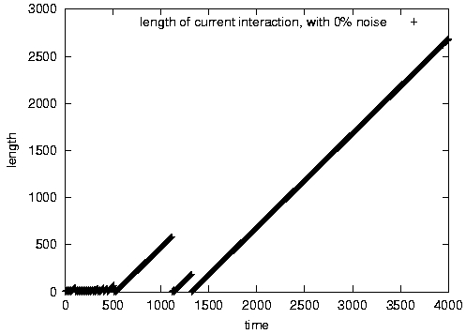
Figure 1- length of current interaction, 3 patterns, noiseless
3.3.2 Influence of learning
The instant match ratio is displayed on figure 2; it allows us to see how the model reacts to pattern changes. It is consistent with the average match ratio, computed from the beginning, and which shows a steady increase (figure 3).

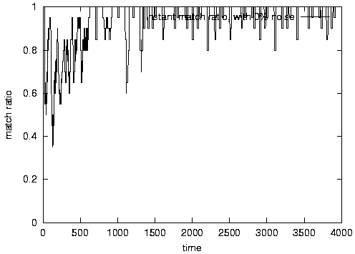
Figure 2- instant match ratio, 3 patterns, noiseless
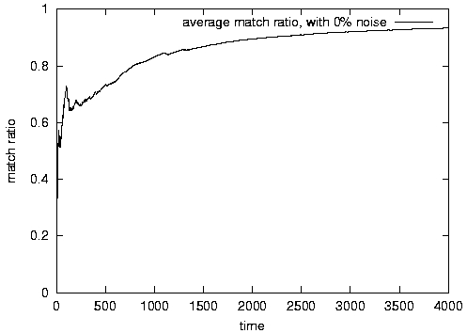
Figure 3- average match ratio, 3 patterns, noiseless
3.3.3 Influence of noise
The influence of noise on the model robustness has been tested by introducing random inversions in the sensory stream. A 5% noise level results in a significant matching impairement (figure 4)
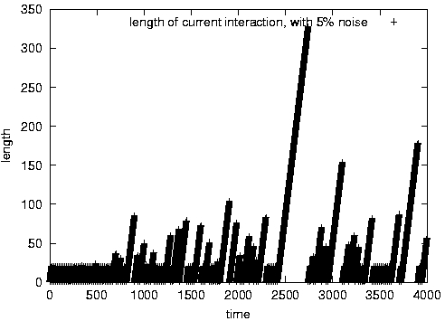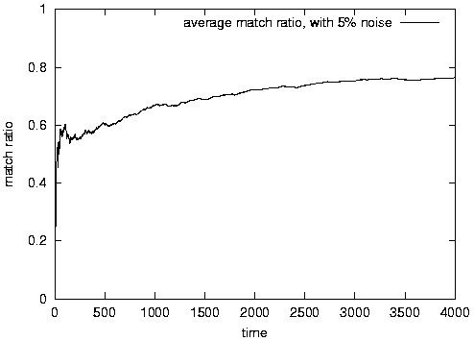
Figure 4- 3 patterns, 5% of random inversions
(left: length of current interaction, right: average match ratio)

4 Conclusion
By differentiation and selection, the interactive perceptual representation allows the emergence of new representations, which is illustrated by our simple example, where an agent learns to distinguish practically (visible in its behavior) patterns in a time series, with no other instruction than to keep active its perceptual system.
The stored interactions model is a new kind of learning framework, with keeps intact each individual experience, and synthesize them on the fly during interaction. Learning and recognition are no longer separated, but are tightly coupled.
Furthermore, interactive representation provides a means to indicate that it is in error, a crucial point for any unsupervised learning system.

References
- Piaget J. The origins of intelligence in children. New-York: Norton, 1952.
- Piaget J. The construction of reality in the child. New York: Basic, 1954.
- Piaget J. Biology and knowledge. Chicago: University of Chicago Press, 1971.
- Drescher G. L. Made-up minds. A constructivist approach to artificial intelligence, MIT Press, 1991.
- Brooks R. Intelligence without representation. Artificial Intelligence, 1991, no. 47, pp. 139-159.
- Scheier C. and Lambrinos D. Categorization in a real-world agent using haptic exploration and active perception. In J. Pollack, P. Maes, M. Mataric and S. Wilson eds., From animals to animats, Proceedings of the fourth International Conference on Simulation of Adaptive Behavior (SAB96), 1996.
- Schmill M. D., Rosenstein M. T., Cohen P. R., Utgoff P. Learning what is relevant to the effect of actions for a mobile robot. In K. P. Sycara and M. Wooldridge eds., Proceedings of the 2nd International Conference on Autonomous Agents (Agents’98), pp. 247-253, ACM Press, New York, 1998.
- Steel L. Perceptually grounded meaning creation. In V. Lesser editor, Proceedings of the First International Conference on Multi-Agent Systems, MIT Press, 1996.
- Edelman G. M. Neural Darwinism. Oxford University Press, 1989.
- Harnad S. The symbol grounding problem. Physics D, no. 42, pp. 335-346, 1990.
- Bickhard M. H.. The emergence of representation in autonomous embodied agents. In Proceedings of the Fall 1996 AAA symposium on embodied cognition and action, 1996.
- Bickhard M. H. and Terveen L. Foundational issues in artificial intelligence and cognitive science. Elsevier, North-Holland, New-York, 1995.
- O’Regan J. K. Solving the ‘real’ mysteries of visual perception: the world as an outside memory. Canadian Journal of Psychology, no. 46, pp. 461-488, 1992.
- Buisson J.-C. A computer model of interactivism and piagetian assimilation applied to visual perception. Paper presented at the 31th Annual Symposium of the Jean Piaget Society, Berkley, 2001.

